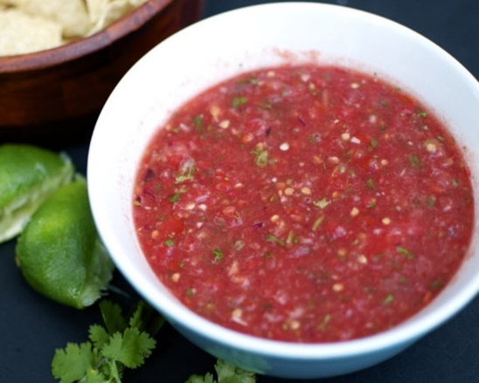
Fresh Blender Salsa Recipe

Prep Time 15 mins Cook Time 30 mins

8 Servings

Ingredients
3 large tomatoes
½ onion
Cilantro
1 lime
1 jalapeno pepper (optional)
Salt and pepper to taste

Directions
- Remove the core from the tomatoes.
- Rough chop tomatoes and onions and put into the blender.
- Add cilantro to taste.
- Squeeze in the juice of one lime. Hint: First roll the lime on the counter to break the fibers that will make it easier to squeeze and provide more juice.
- Slice jalapeno in half vertically. Remove the seeds. Dice it a little and put it into the blender.
- Add salt and pepper.
- Start the blender on slow and build up speed. Stop when you reach the desired degree of chunkiness.
- Pour it in a bowl.
- Let it sit for about an hour to meld the flavors, allow the bubbles to dissipate, and the mix to return to its rich, red color.

